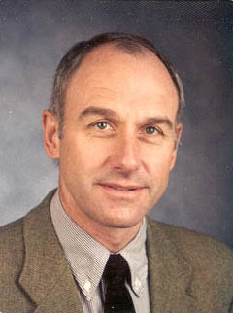
Dr. Manfred F. Buchroithner is Full Professor of Cartography at and Director of the Institute for Cartography (IfC) of the Dresden University of Technology (TUD). He holds degrees in both Geology & Paleontology (Graz, Austria) and Cartography and Remote Sensing (ITC, NL) and obtained his PhD in 1977. Out of his more than 250 articles more than 60 have been published in reviewed journals. He has written three books and edited three volumes on remote sensing. His major research interests cover true-3D geodata visualisation and high-mountain cartography.

AN EDUCATIONAL FILM ABOUT THE CARTOGRAPHIC OEUVRE
OF SVEN HEDIN

Manfred F. Buchroithner
Technische Universität Dresden, Institute for Cartography, Germany
manfred.buchroithner@tu-dresden.de

Abstract

For many years High Asia represents a research focus of the Institute for Cartography (IfC) of the Dresden University of Technology. The question regarding the reliability of ancient maps of this vast and remote region led to the production of an instructional film about the cartographic Oeuvre of the Swedish scholar, explorer and adventurer Sven Hedin. Hedin was the first European who advanced into the interior of the Taklamakan Desert and Tibet. His four expeditions carried out some 100 years ago did not only result in valuable cartographic material but also in general geographical, cultural and ethnological findings. His mappings were the most accurate cartographic sources of Inner Asia until the advent of spaceborne imagery. In cooperation with the Centre for Audio and Video Media (AVMZ) and the Centre for Information Technology Services and High Performance Computing (ZIH) of the TU Dresden the IfC produced a 35-minutes film about Hedin's map-making.

Hedin's Expeditions to High Asia

The film investigates the reliability of historical maps and their potential for comparative research based on the cartographic oeuvre of Sven Hedin (1865 – 1952). The Swedish geographer carried out four expeditions to High Asia between 1893 and 1935: the first one 1893 – 1897, covering 10.498 km, the second one 1899 – 1902, covering 11.647 km, and the third one 1905 – 1909, covering 7.324 km (cf. Figure 1), all of them entering from the west (cf. Forêt 2004). His fourth expedition, organized after a gap of 17 years and totally different in style – i. a. supported by cars – however, started from Beijing.

As one of the first European explorers, his expeditions and investigations focused on the Chinese provinces of Xinjiang and Xizang, formerly known as East Turkestan and Tibet. In spite of harsh conditions regarding climate and terrain he explored and mapped the central regions of the Taklamakan Desert and Tibet as the first Westerner. Hedin published a number of landscape printings, popular and scientific articles, and maps (Hedin 1900, Hedin 1904, Hedin 1917).

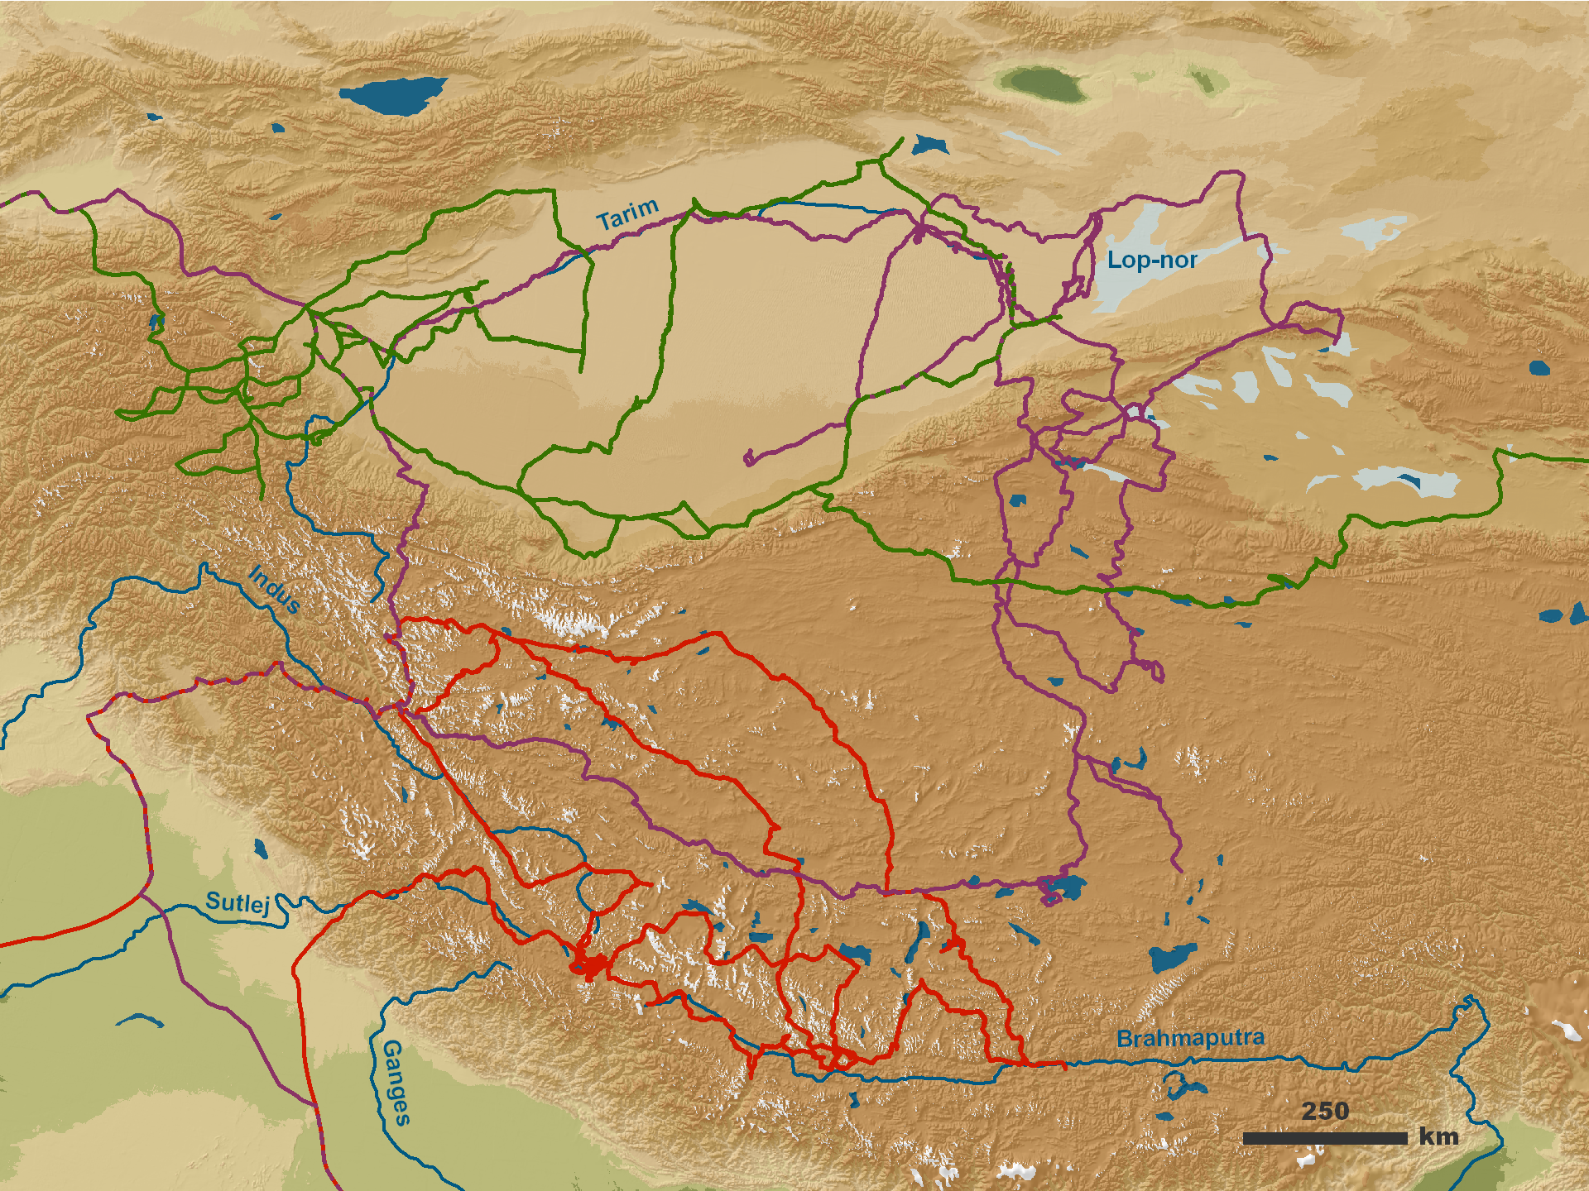
Figure 1: Sven Hedin's first 3 expeditions to Central Asia. First: green, second: violet, third: red. For further explanation see text.

Planning and Logistics of Film Making

The whole project was initiated by of Håkan Wahlquist, Keeper of the Sven Hedin Trust in Stockholm (Sweden), Gerhard Bax from the Uppsala University (Sweden) and the author, all of them having followed Hedin's tracks in Tibet. The film may be used for both historical, geographical and cartographic education in higher schools and universities.

Already in 2005 a first conception has been elaborated for a film entitled “Zwischen Gobi und Himalaja – Über das kartographische Werk von Sven Hedin” (“Between Gobi and Himalaya – The Cartographic Oeuvre of Sven Hedin”). According to this outline the film is mainly supposed to address the topic – mapping and maps - itself, whereas Hedin’s life and his expeditions will only be presented on the basis of historical film material, ancient photographs and overflight animations illustrating his routes. The final editing and dubbing connected the individual sequences of the story board derived from the initial conception.

Based on this conception of the film contents a storyboard containing every single scene was elaborated. This storyboard subsequently served for the cutting and sound recording. It turned out that some changes had to be made in order to visualize the contents of the film as efficient as possible and to interest or even fill the audience with enthusiasm. In order to establish a connection to present times a framework plot was designed whose emphasis are represented by the environmental changes through the human beings. The continuously recurring example for these changes is Lake Lop-nor situated in the Taklamakan Desert, one of the major objects of Sven Hedin's expeditions. Despite the initially envisaged plan for six animated cartographic overflight simulations only three where realised. Also the number of the integrated small-scale maps was reduced. The storyline, however, was extended by so-called "space zooms" (zooms from "space" into the respective areas of interest) which served for the introduction of the routes of Hedin's big expeditions. For the film title a similar zoom was generated. For the making of these virtual design elements the animation software MAYA was used. The provision of comprehensive film material through the Zweites Deutsches Fernsehen (ZDF) and the Dresden-based Alpine journalist Frank Meutzner it was possible to integrate a significant number of scenes taken in the field.

Out of many interviews led in Sweden and Germany only a small subset was used for the final film version. Also, the initially envisaged intensive treatment of the relationship between Hedin and the leading geographer of his days, Ferdinand von Richthofen, was not realized as planned. Instead, the connection of Hedin with the map publishing house Justus Perthes in Gotha was elaborated more explicitly.

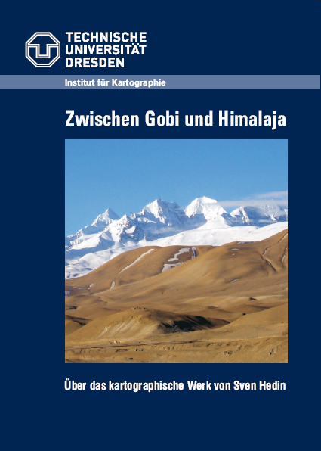
Figure 2: Front page of DVD cover.

Film Production

The compilation and final cutting of the footage material was made at the digital cutting station of the Centre for Audio and Video Media (AVMZ) of the TU Dresden, using the AVID Media Composer Software.

The initially planned production in the HDV format could not be materialized, mainly due to the frequent use of historical film material. The format of the choice was therefore PAL plus with a format of 16:19. For the final output of the film on DVD the format MPG-2 was used. This enables a playing by means of PC, DVD player, TV screen or beamer.

Since the emphasis of the film lies on Hedin's cartographic work, a major aspect of the film deals with accuracy assessment of Hedin's General Map of Southern Tibet and East Turkestan (cf. Hedin 1966). By means of four selected areas, differences in the geometric quality of Hedin's maps are studied and visualized (cf. Jenny 2005).

In the second half of 2006 the footage material was composed and cut at the AVMZ of the Dresden University of Technology, finally resulting in an educational film dubbed in German language. For the use by a broader audience the production of a Swedish and an English version is envisaged. This would also allow the integration of the film into the permanent exhibition about Sven Hedin in the Ethnografiska Museet in Stockholm. Table 1 lists both staff, length and display format of the film.

Table 1: Imprint of the Film.
Idea and Scient. Direction: | Prof. Dr. Manfred Buchroithner
Editors: | Antje Oppitz, Klaus Habermann
Storyboard: | Dieter Berger, Klaus Habermann
Animation: | Ingrid Zimmermann
Music: | Jorge Garcia del Valle Méndez
Direction: | Dieter Berger
Length: | 34 minutes
Format: | PAL 16:9/German

Due to the high variability regarding different displays like digital flat panels and plasma panels an MPEG-2 encoded DVD was produced in March 2007. More detailed information about the whole film project can be obtained from Oppitz 2007.

References

Forêt, Ph., 2004: La véritable histoire d’une montagne plus grande que l’Himalaya – Les résultats scientifiques inattendus d’un voyage au Tibet (1906 – 1908) et la querelle du Transhimalaya. Philippe Forêt, Collection: D'autre part, 1st Ed., Publ. Bréal 2004.
Hedin, S., 1900: Die geographisch-wissenschaftlichen Ergebnisse meiner Reisen in Zentralasien 1984-1897. Ergänzungsheft Nr.131 zu Petermanns Mitteilungen, Gotha.
Hedin, S. et al., 1904: Scientific Results of a Journey in Central Asia 1899-1902, 6 text volumes, 2 map volumes, Lithographical Institute of the General Staff of the Swedish Army, Stockholm 1904-07.
Hedin, S., 1917: Southern Tibet. Discoveries in former Times compared with own Researches 1906-08. 9 textvolumes, 2 map volumes, Lithographical Institute of the General Staff of the Swedish Army, Stockholm 1917-22.
Hedin, S., 1966: Reports from the Scientific Expedition to the North-Western Provinces of China under the Leadership of Dr. Sven Hedin. Publ. 47 (Vol. I/I): Central Asia Atlas 1: 1.000.000, Sven Hedin, Nils P. Ambolt, Erik Norin.
Jenny, B. and Weber, A., 2005: MapAnalyst - The Map Historian's Tool for the Analysis of Old Maps. Institute for Cartography, Swiss Federal Institute of Technology Zurich, URL: http://mapanalyst.cartography.ch
Oppitz, A., 2007: Erstellung eines Lehrfilms mit dem Thema: Zwischen Gobi und Himalaja – Über das kartographische Werk von Sven Hedin. Diploma Thesis, Institute for Cartography, Dresden University of Technology, unpublished.

